**REST - Get country based on country code   
  
Write a REST service that returns a specific country based on country code. The country code should be case insensitive.**

**File: src/main/resources/country.xml**

**CODE :-**  
<?xml version="1.0" encoding="UTF-8"?>

<beans xmlns="http://www.springframework.org/schema/beans"

xmlns:xsi="http://www.w3.org/2001/XMLSchema-instance"

xsi:schemaLocation="http://www.springframework.org/schema/beans

http://www.springframework.org/schema/beans/spring-beans.xsd">

<bean id="countryList" class="java.util.ArrayList">

<constructor-arg>

<list>

<bean class="com.cognizant.spring_learn.Country">

<property name="code" value="US"/>

<property name="name" value="United States"/>

</bean>

<bean class="com.cognizant.spring_learn.Country">

<property name="code" value="DE"/>

<property name="name" value="Germany"/>

</bean>

<bean class="com.cognizant.spring_learn.Country">

<property name="code" value="IN"/>

<property name="name" value="India"/>

</bean>

<bean class="com.cognizant.spring_learn.Country">

<property name="code" value="JP"/>

<property name="name" value="Japan"/>

</bean>

</list>

</constructor-arg>

</bean>

</beans>

Location:  
**src/main/java/com/cognizant/spring_learn/service/CountryService.java**

**CODE :-**

package com.cognizant.spring_learn.service;

import com.cognizant.spring_learn.Country;

import org.springframework.context.ApplicationContext;

import org.springframework.context.support.ClassPathXmlApplicationContext;

import org.springframework.stereotype.Service;

import java.util.List;

@Service

public class CountryService {

public Country getCountry(String code) {

ApplicationContext context = new ClassPathXmlApplicationContext("country.xml");

List<Country> countries = context.getBean("countryList", List.class);

return countries.stream()

.filter(c -> c.getCode().equalsIgnoreCase(code))

.findFirst()

.orElse(null); // Optional: Handle null response better if needed

}

}

**File: CountryController.java**

**Location: com.cognizant.spring_learn.controller**

**CODE :-**

package com.cognizant.spring_learn.controller;

import com.cognizant.spring_learn.Country;

import com.cognizant.spring_learn.service.CountryService;

import org.springframework.beans.factory.annotation.Autowired;

import org.springframework.web.bind.annotation.*;

@RestController

public class CountryController {

@Autowired

private CountryService countryService;

@GetMapping("/country/{code}")

public Country getCountry(@PathVariable String code) {

return countryService.getCountry(code);

}

}

**OUTPUT IN BROWSER :-**

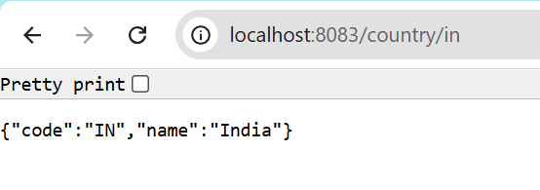

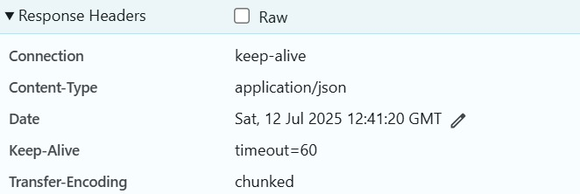

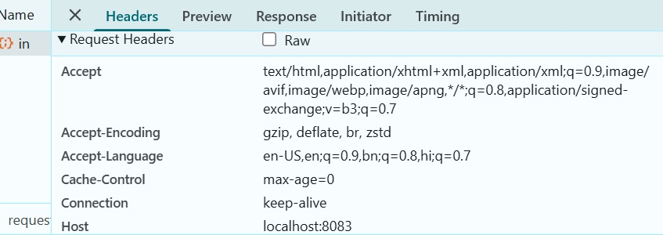

**OUTPUT IN POSTMAN :-**

